METRO TICKET BOOKING SYSTEM
6 Project Documentation

PROJECT REPORT
Developed Using ServiceNow
1. INTRODUCTION
1.1 Project Overview
Metro Ticket Booking System is a ServiceNow-based digital transportation management application developed to automate metro ticket booking, student pass management, payment processing, QR ticket generation, and complaint management.
Traditional metro ticketing systems often require physical counters, manual pass verification, and paper-based complaint handling. These approaches result in long queues, delays, and inefficient management of passenger information.
The Metro Ticket Booking System provides a centralized portal where passengers and students can:
• Book metro tickets online
• Apply for student passes
• Make online payments
• Generate QR tickets
• Track bookings and passes
• Raise complaints
• View payment history
The application automates fare calculations, payment validation, pass generation, and complaint tracking using ServiceNow workflow automation capabilities.
Supported Services
Passenger Services
• Metro Ticket Booking
• QR Ticket Generation
• Payment Processing
• Booking History
• Complaint Management
Student Services
• Student Verification
• Student Pass Application
• Discounted Travel Pass
• Pass Renewal
• Pass Tracking
Administrative Services
• Booking Management
• Revenue Monitoring
• Complaint Resolution
• Route Management
• Station Management
• Fare Management
1.2 Purpose
• Digitize metro ticket booking operations
• Eliminate manual ticket generation
• Automate fare calculation
• Provide student travel discounts
• Improve passenger experience
• Centralize metro operations
• Enable real-time monitoring
• Improve complaint handling efficiency
2. IDEATION PHASE
2.1 Problem Statement
Metro transportation systems often face operational challenges such as:
Existing Problems
• Long ticket booking queues
• Manual fare calculation
• Paper-based passes
• Limited booking visibility
• Difficult complaint tracking
• Revenue monitoring issues
Need
A centralized automated system that can:
• Manage bookings
• Generate digital tickets
• Process payments
• Provide student concessions
• Monitor metro operations

2.2 Empathy Map Canvas
Users:
Passengers, Students, Metro Staff, Finance Administrators, Metro Administrators
Think
• I need quick ticket booking.
• I want easy payment options.
• I need discounted student travel.
Feel
• Frustrated by long queues.
• Concerned about payment failures.
• Need faster complaint resolution.
Say
• Where is my ticket?
• Is my pass approved?
• Why is payment not updated?
Do
• Book metro tickets
• Apply for passes
• Make payments
• Raise complaints
Pain Points
• Manual booking
• Slow verification
• Payment delays
• Lack of transparency
Gains
• Online booking
• QR-based travel
• Automated fare calculation
• Faster complaint handling

2.3 Brainstorming
Problem | Solution
Manual Ticket Booking | Online Booking Portal
Fare Calculation Errors | Automated Fare Engine
Student Verification Delays | Verification Workflow
Manual Ticket Validation | QR Ticket Generation
Complaint Tracking Issues | Complaint Management Module
Revenue Monitoring Issues | Admin Dashboard

3. REQUIREMENT ANALYSIS
3.1 Customer Journey Map
Stage | User Action | System Response
Registration | User accesses portal | Portal loads
Booking | User submits booking | Booking created
Fare Calculation | User selects stations | Fare calculated
Payment | User pays fare | Payment processed
QR Generation | Payment successful | QR generated
Travel | User travels | Ticket validated
Complaint | User raises issue | Complaint recorded

3.2 Functional Requirements
Passenger Module
• Create booking
• View booking history
• View payment history
• Raise complaints
Student Module
• Student verification
• Pass application
• Pass renewal
• Pass tracking
Payment Module
• Payment creation
• Payment status tracking
• Transaction reference storage
Complaint Module
• Complaint creation
• Complaint tracking
• Complaint resolution
Administration Module
• Manage stations
• Manage routes
• Manage fare matrix
• Dashboard monitoring
Non-Functional Requirements :
Availability
System available 24/7
Reliability
Secure transaction processing
Performance
Fast ticket generation
Security
Role-based access control
Scalability
Support growing passenger volume

3.3 Technology Stack :
Component | Technology
Platform | ServiceNow
Database | Custom Scoped Tables
Workflow | Flow Designer
UI | UI Builder
Business Logic | Business Rules
Reusable Logic | Script Includes
Security | Roles & ACLs
Notifications | ServiceNow Notifications
Reporting | Dashboard Components

Reporting: Dashboard Components
4. PROJECT DESIGN
4.1 Database Design
Table Name | Description
Metro Passenger | Stores passenger details.
Metro Station | Stores station information.
Metro Route | Stores route information.
Metro Fare Matrix | Stores fare rules and fare calculation data.
Metro Booking | Stores ticket booking details.
Metro Student Profile | Stores student information.
Metro Student Pass | Stores student pass details.
Metro Payment | Stores payment transactions.
Metro QR Ticket | Stores generated QR ticket information.
Metro Complaint | Stores complaint records.

4.2 Fare Calculation Engine
Metro Fare Calculator :
The Script Include performs : Normal Fare Calculation

calculateNormalFare()
Calculates fare based on :
- Source Station
- Destination Station
- Passenger Count
Student Pass Calculation :
calculateStudentPassAmount()
Calculates:
- Weekly Pass
- Monthly Pass
- Student Discount
Fare Matrix Lookup :
_getBaseFare()
to retrieve fare from : Metro Fare Matrix
Student Discount Lookup :
_getStudentDiscount()
to calculate discounted pass prices.

4.3 Solution Architecture
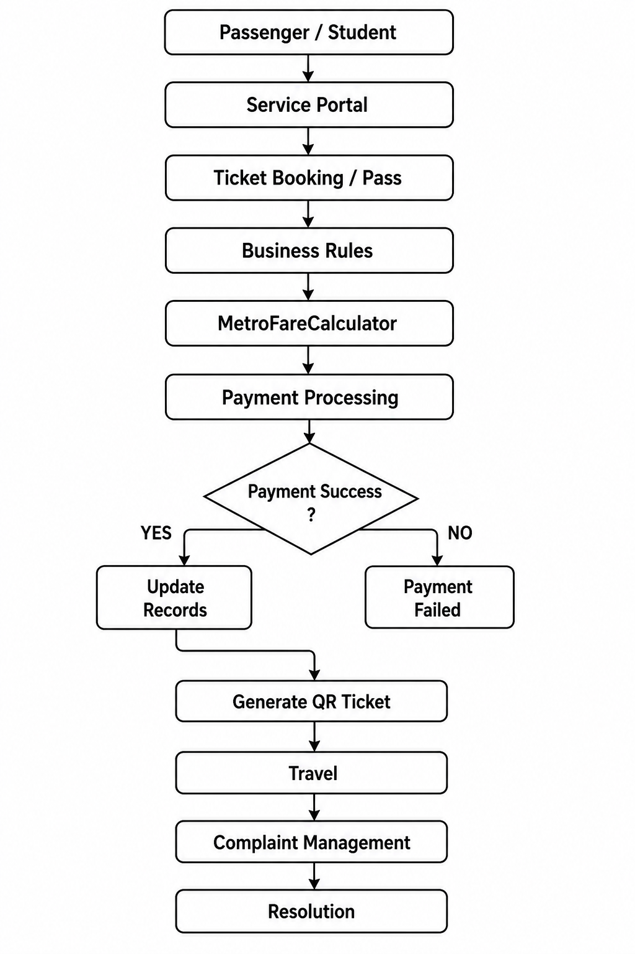
5. PROJECT IMPLEMENTATION
Role Configuration
Metro Admin
Responsibilities:
- Full system access
- Manage routes
- Manage fares
- Monitor revenue
Finance Admin
Responsibilities:
- Payment management
- Refund handling
- Revenue monitoring
Station Staff
Responsibilities:
- QR validation
- Pass verification
Student
Responsibilities:
- Apply for passes
- View pass history
Passenger
Responsibilities:
- Book tickets
- Raise complaints
6. SERVICE PORTAL IMPLEMENTATION
Pages:
Home
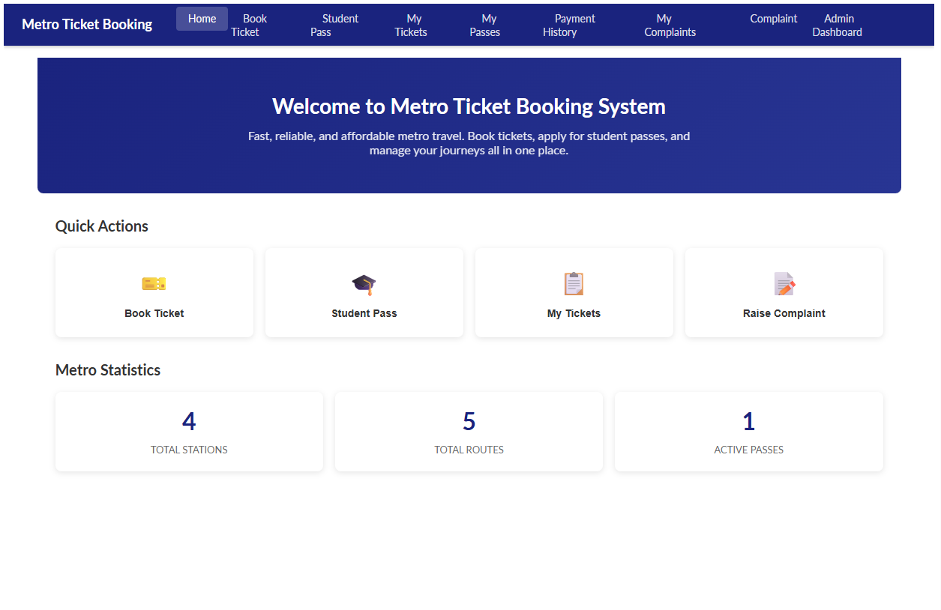Book Ticket :
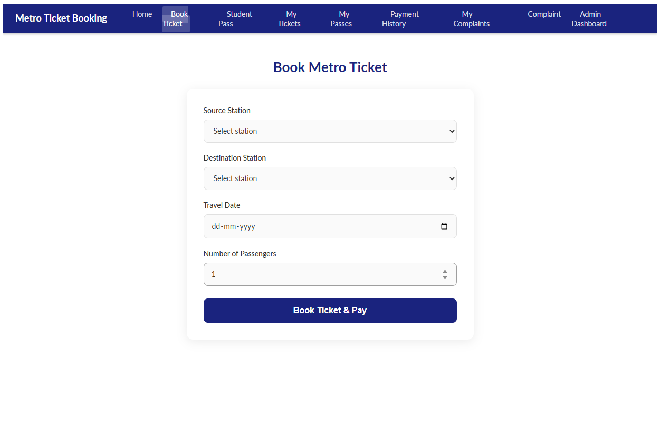

Student Pass :
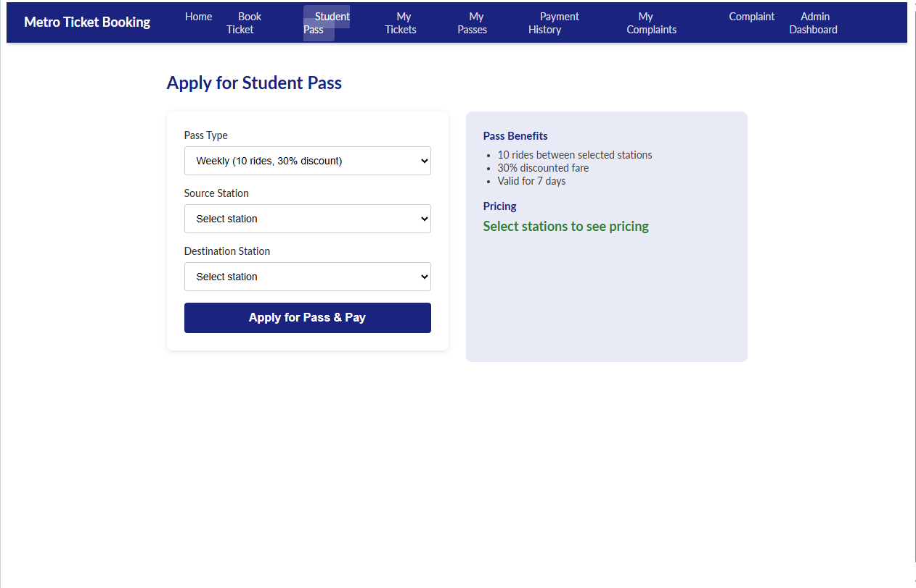
My Tickets :
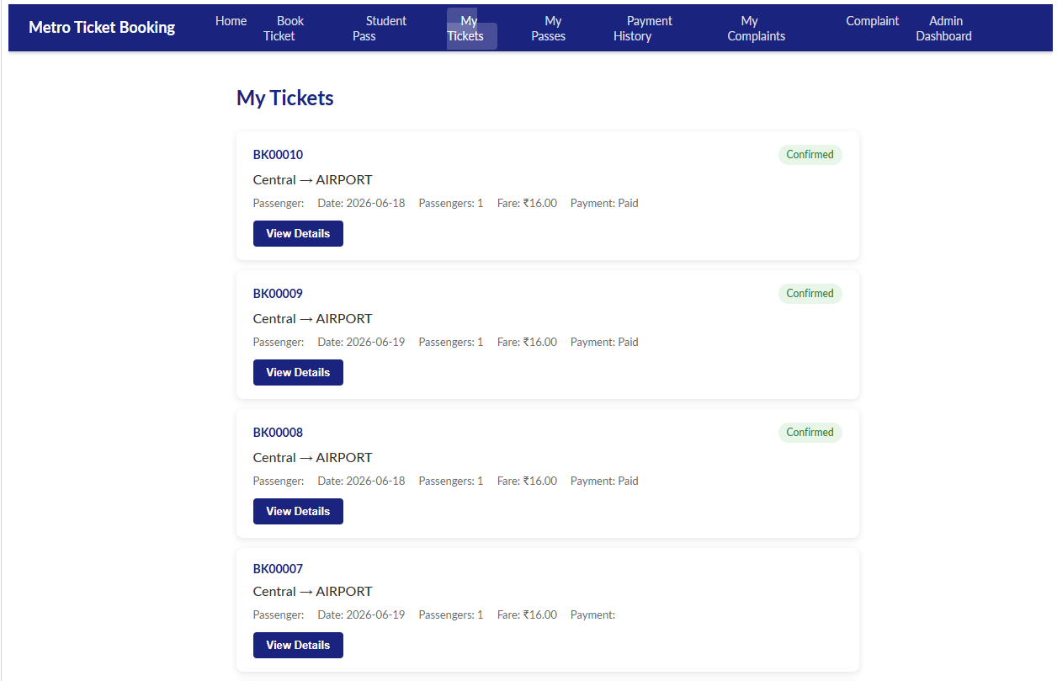
My Student Passes :
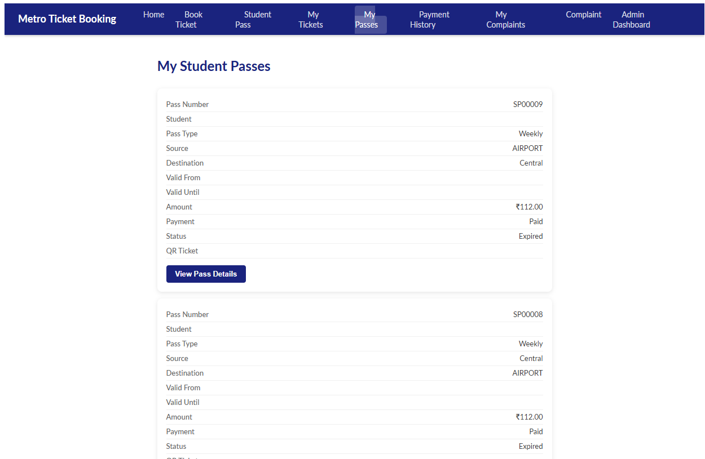
Payment History :
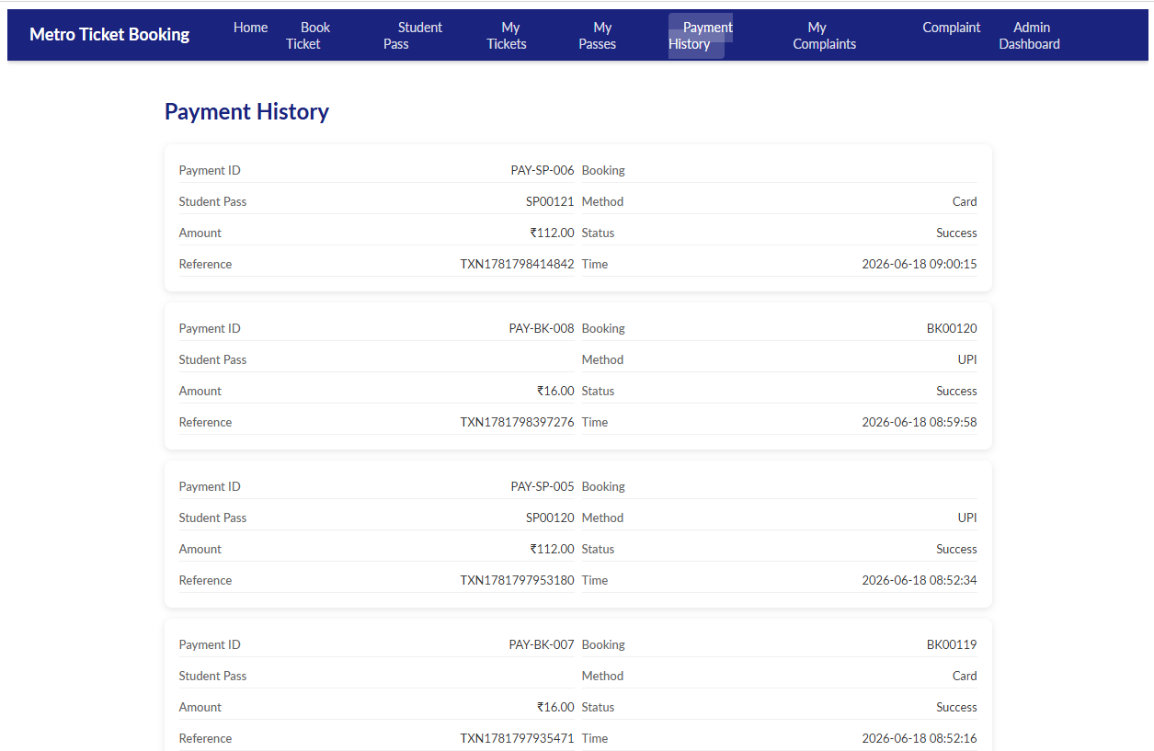
Complaint :
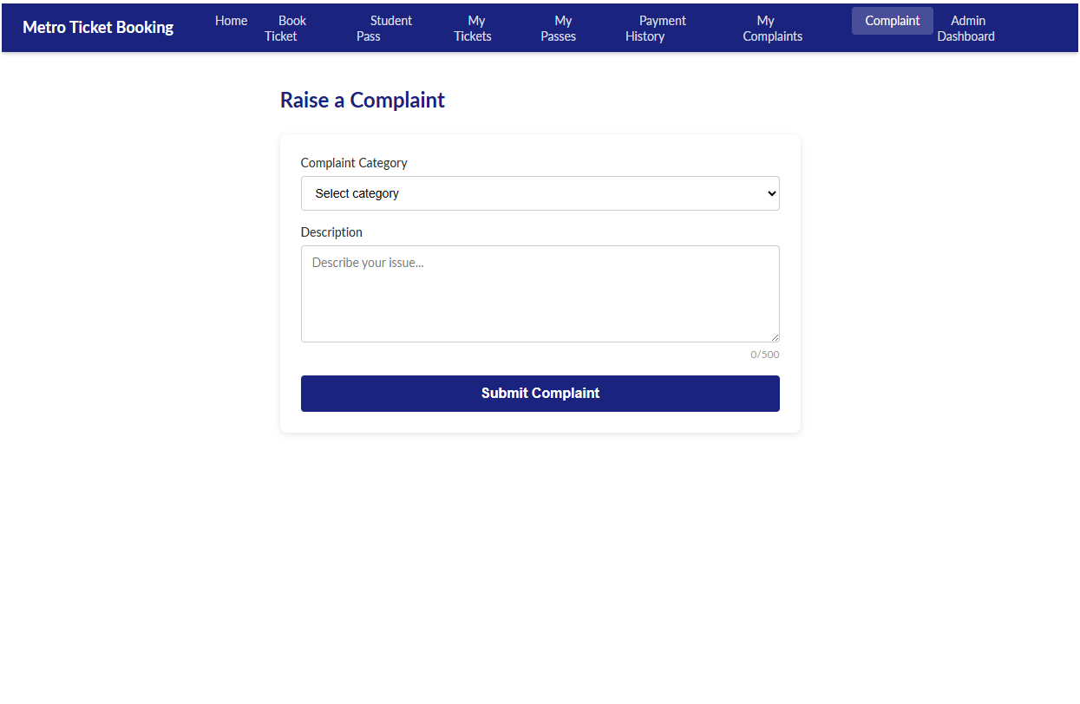My Complaints :
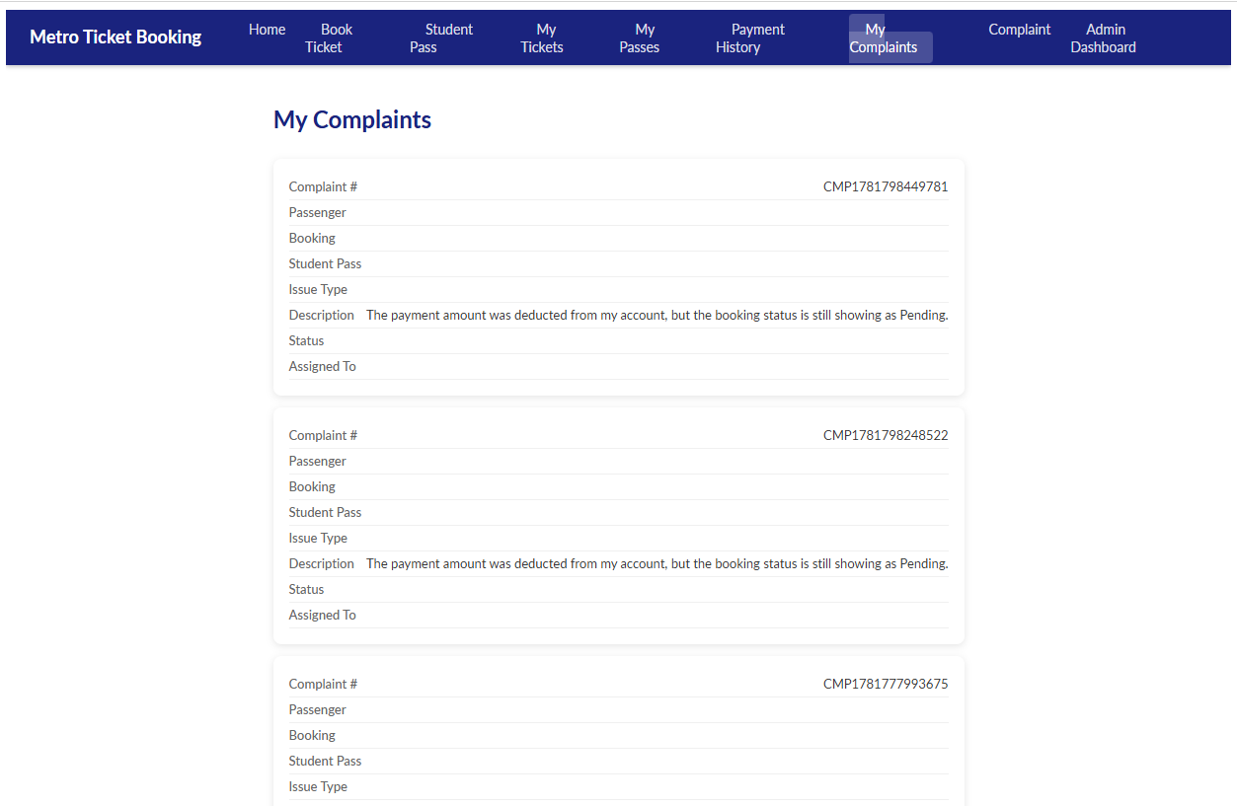
Admin Dashboard :
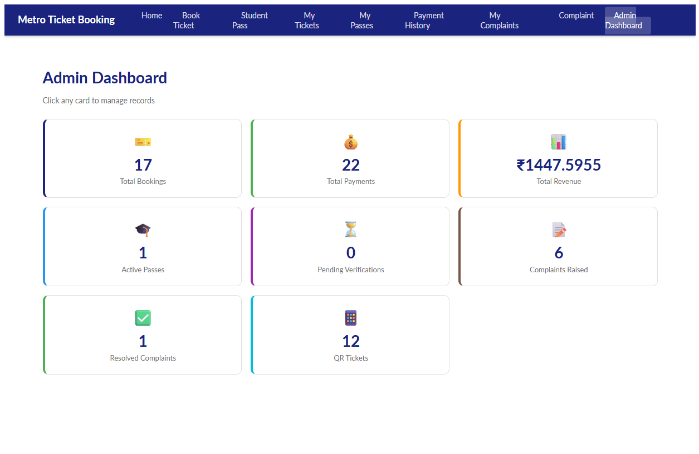
Admin Dashboard KPIs:
Total Bookings :
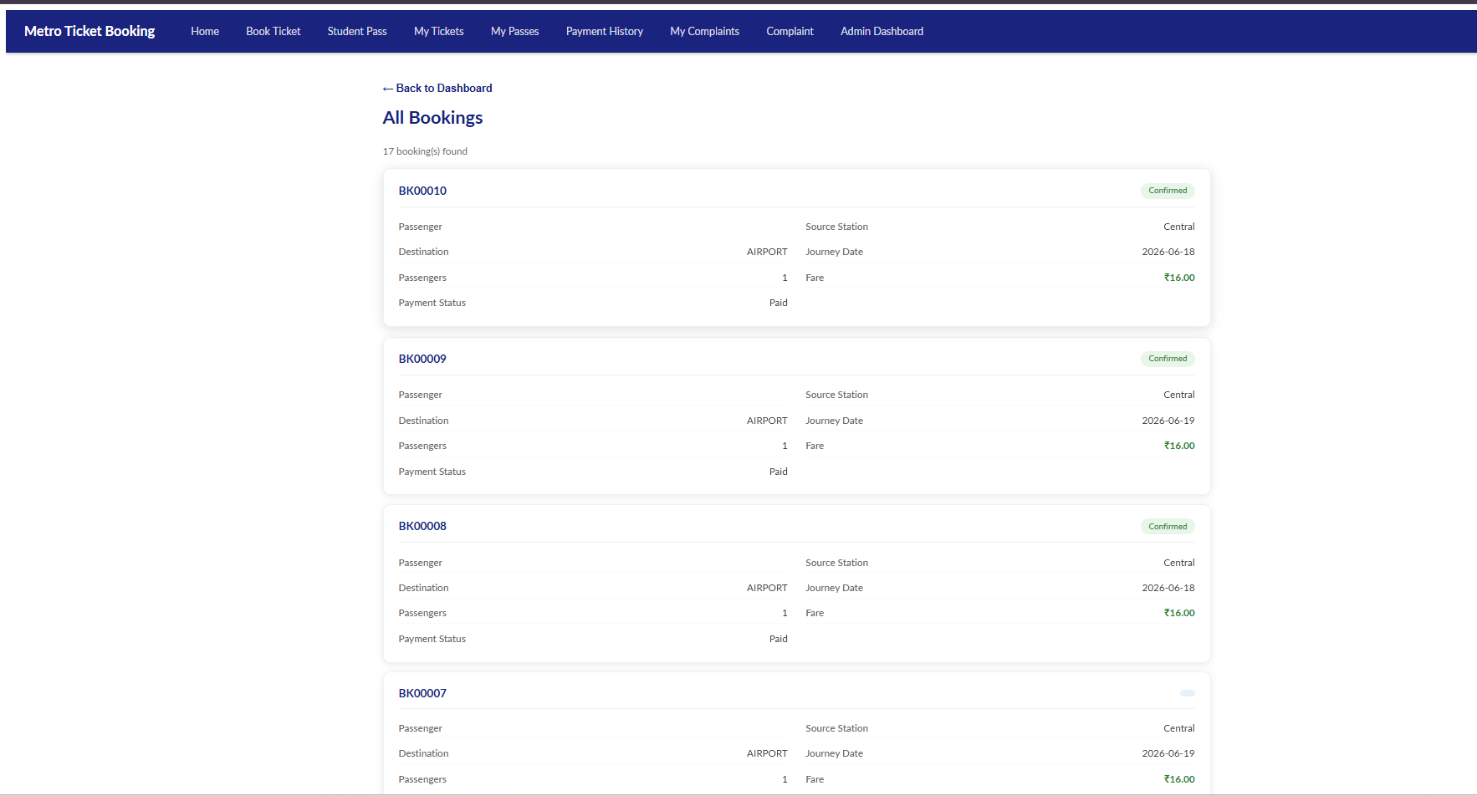

Total Payments :
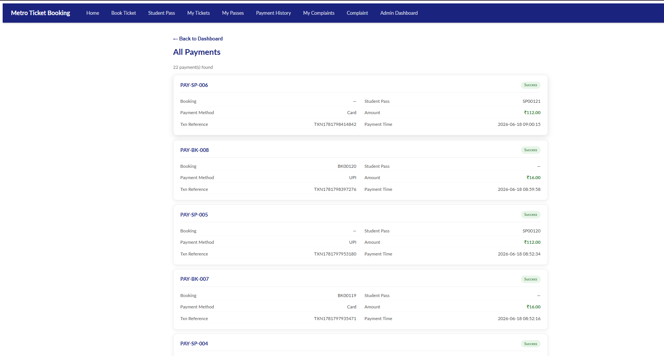
Revenue : 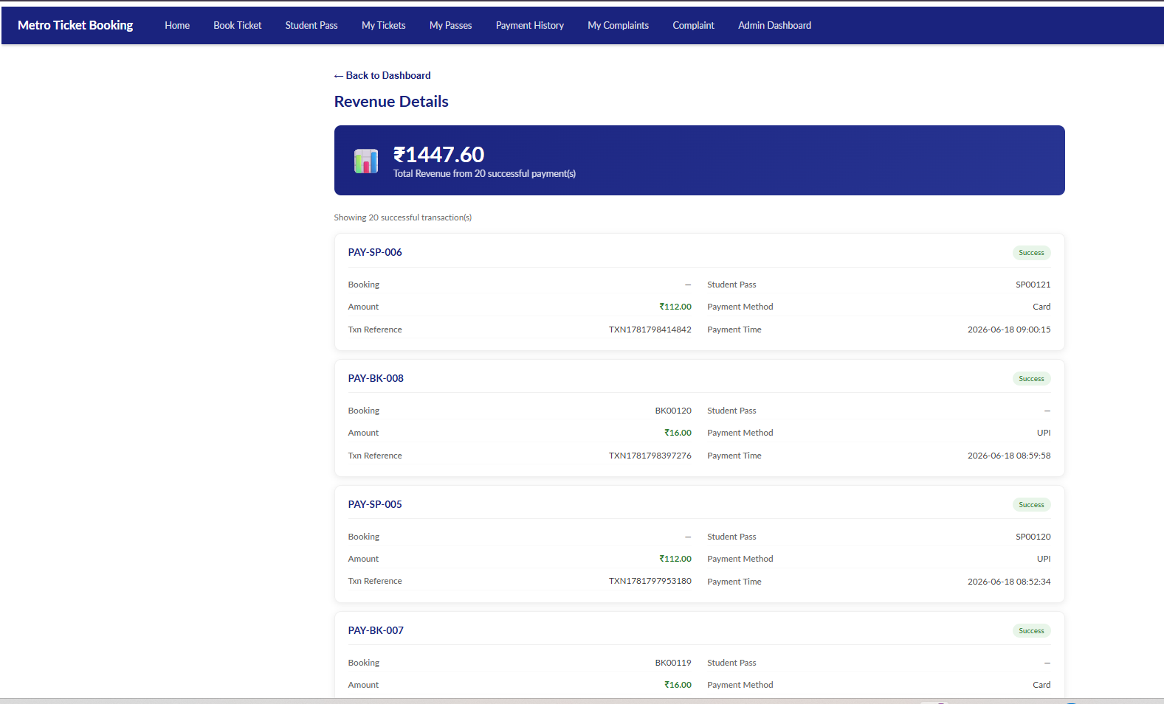
Active Passes : 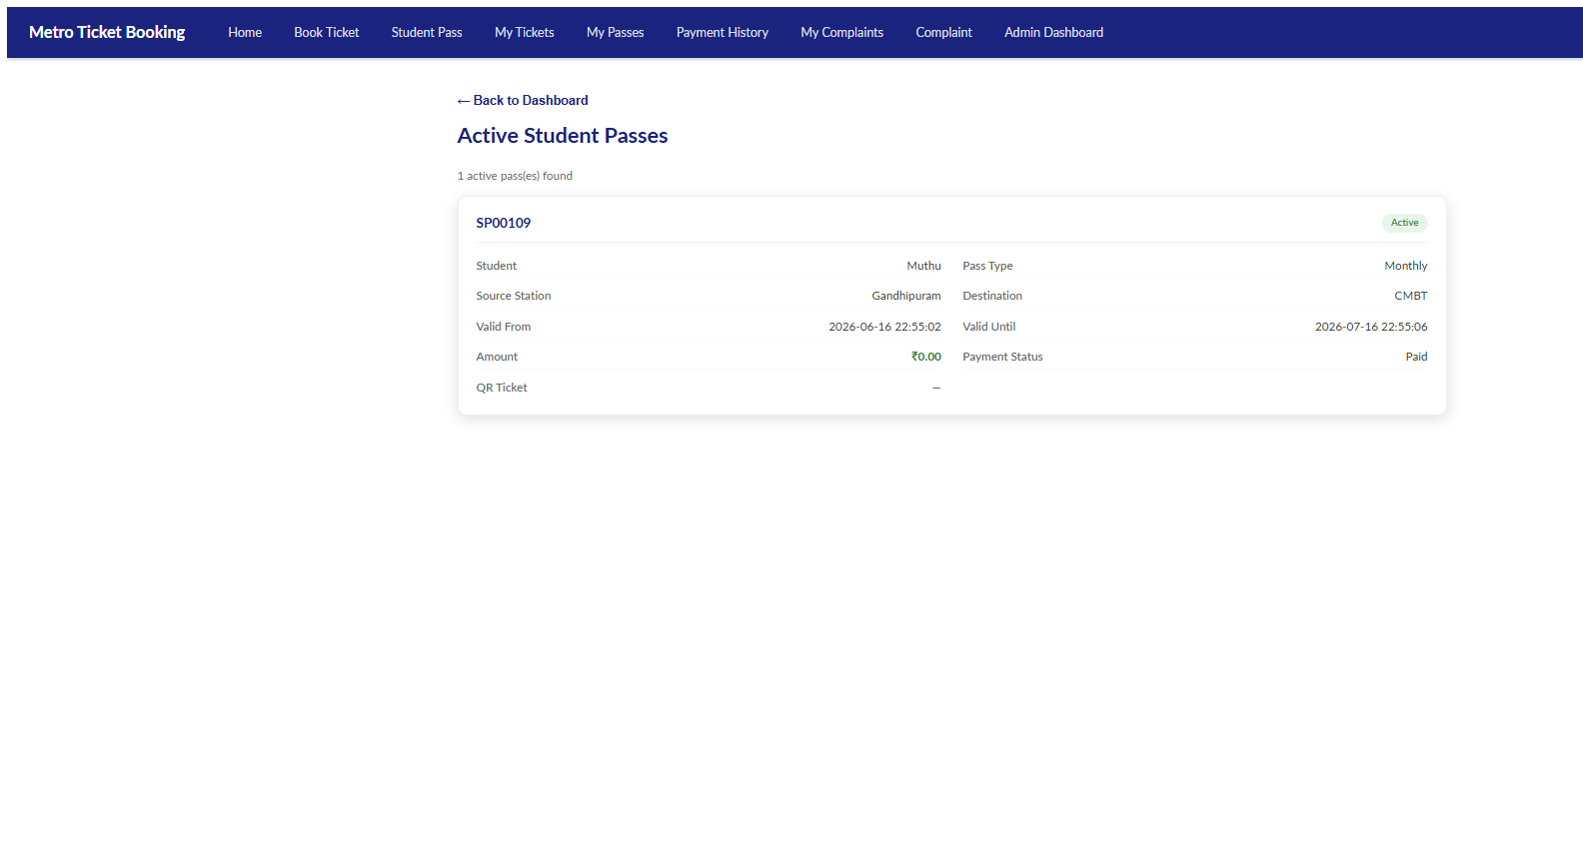
Pending Verifications : 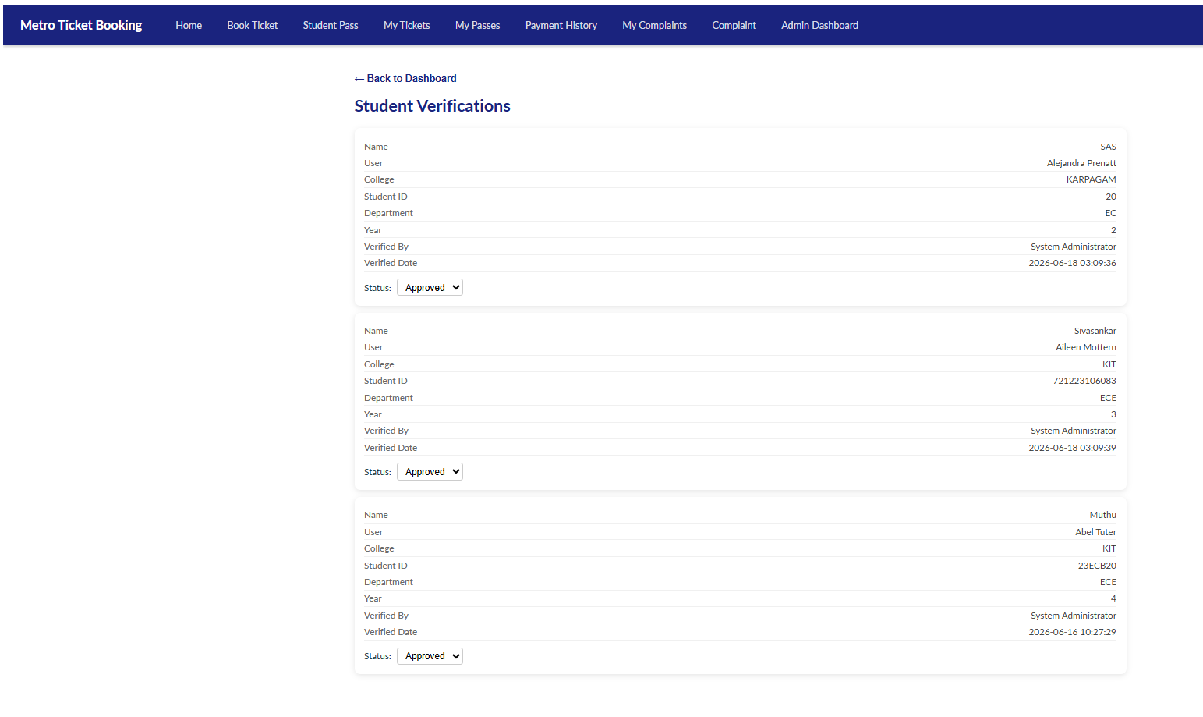

Complaints Raised : 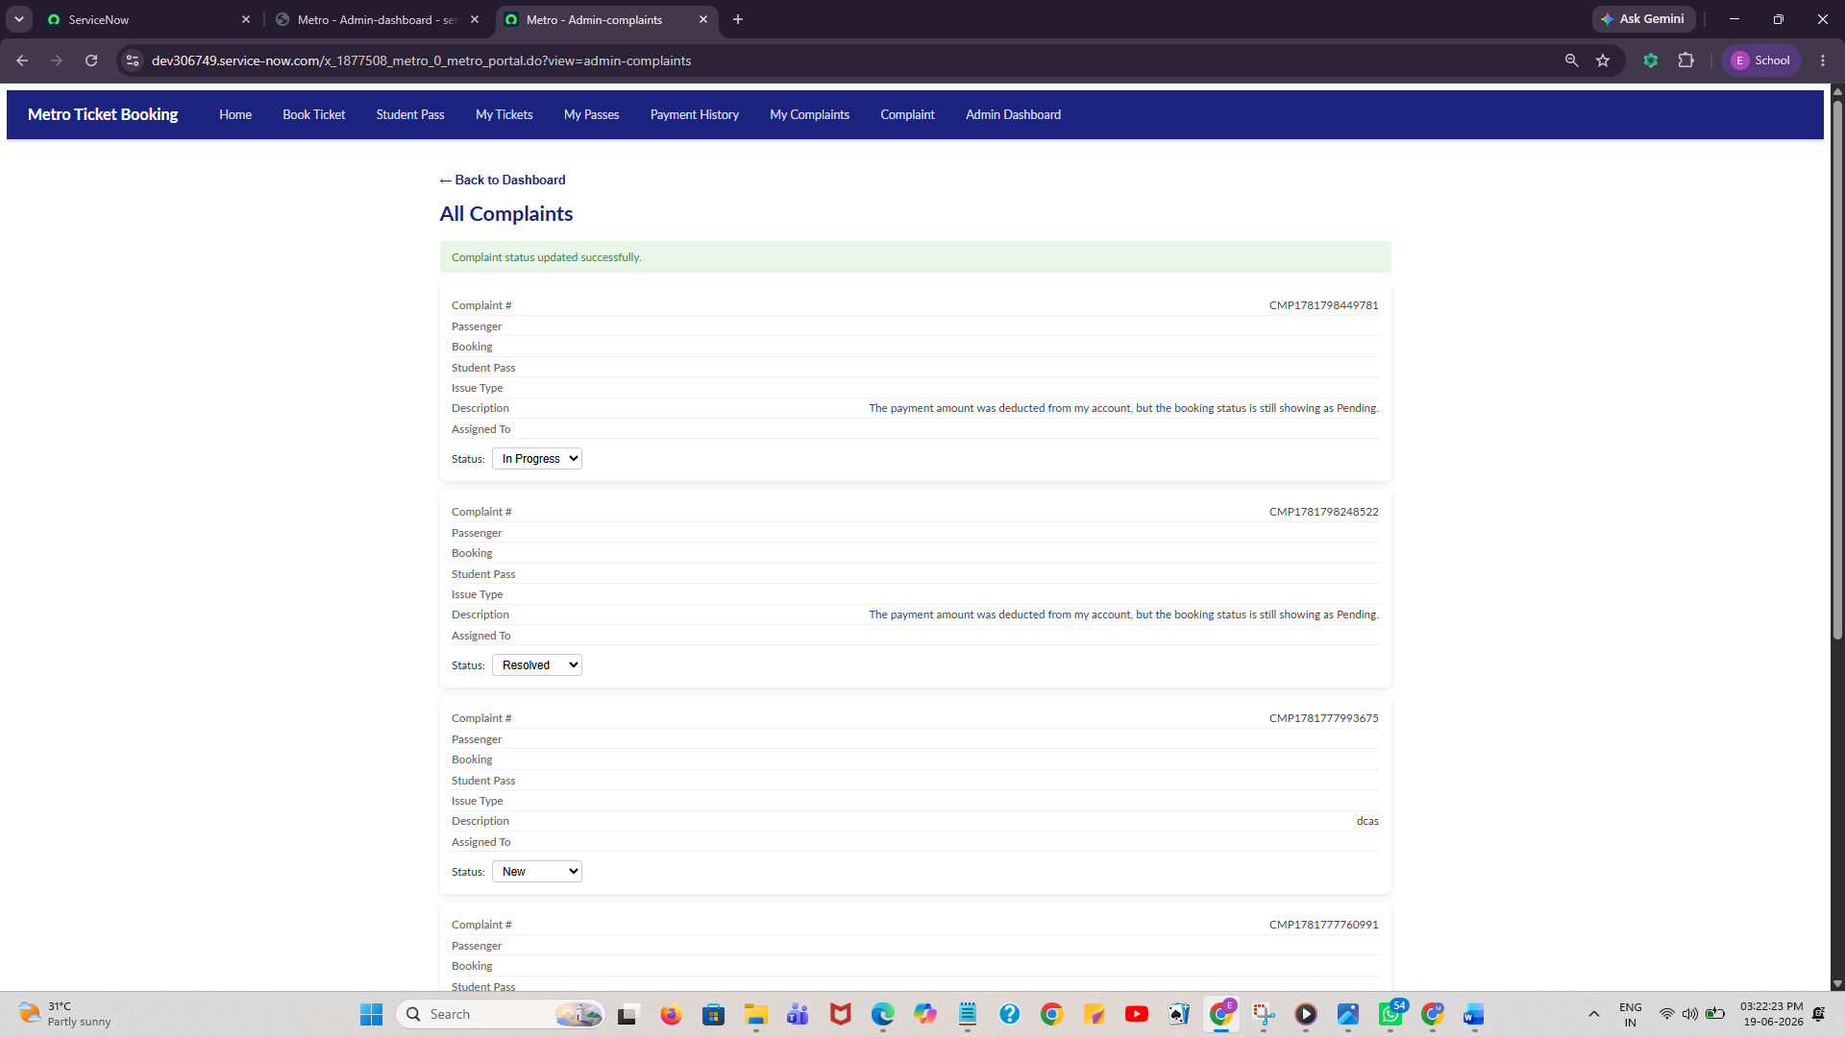
Resolved Complaints :
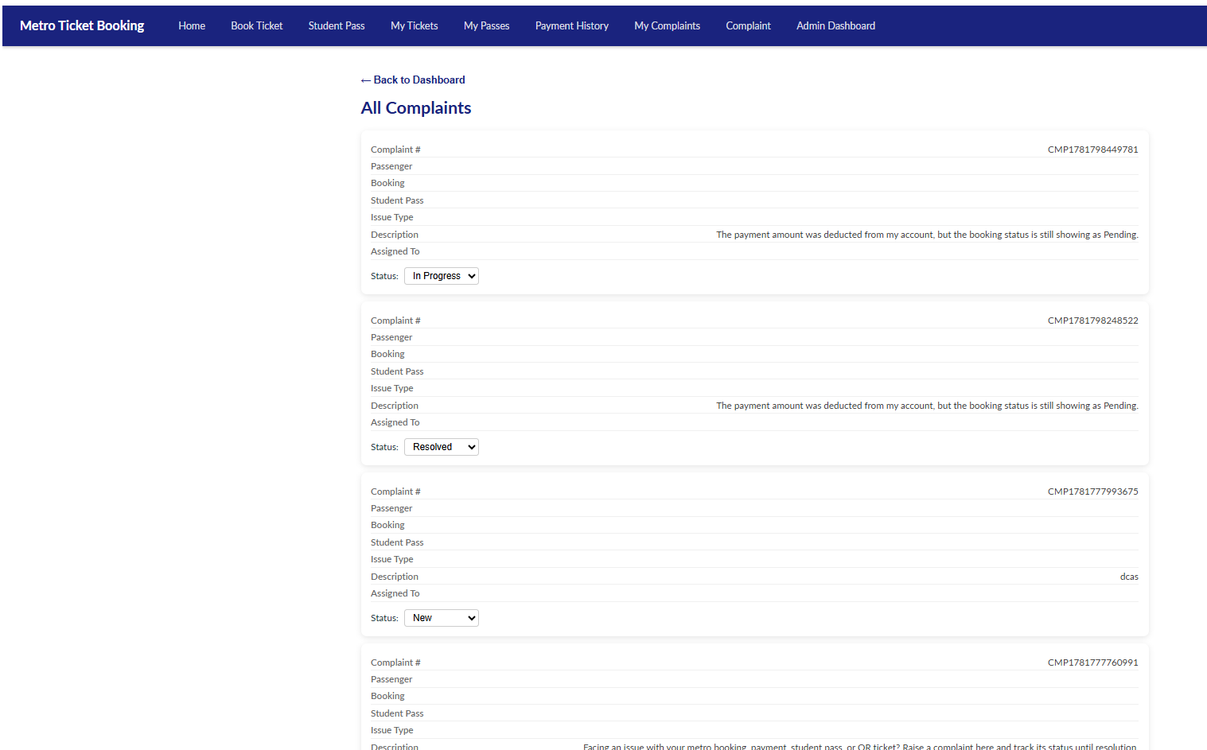

QR Tickets Generated :
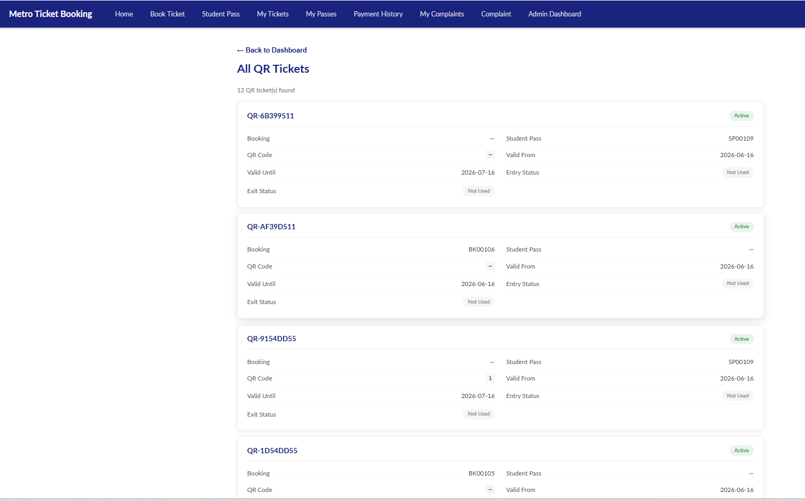

7. TESTING
Test Case | Expected Result | Status
Ticket Booking | Booking Created | Pass
Fare Calculation | Correct Fare | Pass
Student Pass | Pass Created | Pass
Payment Processing | Payment Updated | Pass
QR Generation | QR Generated | Pass
Complaint Creation | Complaint Created | Pass
Dashboard Update | Metrics Updated | Pass

8. RESULTS
• Automated ticket booking
• Automated fare calculations
• Enabled student concessions
• Generated QR tickets
• Managed complaints
• Monitored payments
• Provided dashboard analytics
9. ADVANTAGES
• Online ticket booking
• Automated fare calculation
• Student discounts
• QR-based travel
• Complaint tracking
• Revenue monitoring
• Role-based security
• Centralized management
10. DISADVANTAGES
• Initial configuration effort
• ServiceNow licensing requirement
• Dependence on internet connectivity
• Requires user training
11. CONCLUSION
The Metro Ticket Booking System successfully digitizes metro transportation services through ServiceNow and integrates booking management, student pass automation, payment processing, QR ticket generation, complaint handling, and administrative analytics into a single platform.
12. FUTURE SCOPE
• AI-based fare recommendations
• Mobile application integration
• UPI gateway integration
• Live train tracking
• QR scanner mobile app
• Multi-city metro support
• Predictive passenger analytics
• Virtual Agent integration
• Real-time notifications
• Smart travel card integration

